Article
AUMOR: Augmented-Reality Based Mobile Application for University Orientation
Muhammad Nadeem ^{1,}*, Melinda Oroszlanyova ¹, Pauly Awad ¹, Hasan Ozkan ², and Svetlana Beryozkina¹
Academic Editor: Firstname Lastname
Received: date
Revised: date
Accepted: date
Published: date
Citation: To be added by editorial staff during production.
Copyright: © 2025 by the authors. Submitted for possible open access publication under the terms and conditions of the Creative Commons Attribution (CC BY) license (https://creativecommons.org/licenses/by/4.0/).
¹ College of Engineering and Technology, American University of the Middle East, Egaila 54200, Kuwait
² College of Business Administration, American University of the Middle East, Egaila 54200, Kuwait

¹ *Correspondence: muhammad.nadeem@aum.edu.kw
Abstract: Fresh engineering students are often required to absorb a large amount of new information within a short period of time, which can be both academically and emotionally challenging. In response to this challenge, this study introduces AUMOR, a mobile application designed to enhance university orientation by delivering contextual information at the point of need. The application integrates GPS-based localization with QR code triggers to provide real-time, location-specific guidance and interactive content through an augmented reality (AR) interface. It uses GPS functionality to provide real-time location-based services including information about academic buildings, student services, and recreational facilities. The QR code placed on devices and lab equipment provides relevant information upon scanning. The efficacy of the application was evaluated through a user study involving 128 participants which included both the faculty members and students using a Technology Acceptance Model (TAM)-based survey and usability assessments. Key evaluation metrics included Perceived Usefulness, Perceived Ease of Use, Attitude Toward Use, Behavioral Intention to Use, and Actual Use, analyzed using reliability testing and correlation analysis. The results demonstrate that AUMOR improves users’ spatial awareness during orientation by providing them with important information when needed. This improves navigation confidence, and efficiency in locating campus facilities, while demonstrating high levels of usability and acceptance. The findings suggest that AR-based, context-aware mobile applications such as AUMOR can provide a scalable solution for smart campus environments and contributes to the broader field of context-aware mobile learning and AR-assisted navigation.
Keywords: Augmented Reality (AR), Mobile application, University orientation, GPS Navigation, QR Codes, Technology acceptance model (TAM), Context appropriate information
- Introduction
Every year, many students leave college and enter universities to become successful professionals. As institutions of higher learning, universities are crucial for helping students develop their intellectual capacity and prepare for workforce demands [1], [2]. Fresh students often face problems in navigating campus and obtaining information about related buildings and departments. They also face problems in labs due to a difficult transition from theoretical coursework to practical work. They have to learn about safety protocols and equipment crucial for smooth workflow. Before being permitted to work in the lab, students at many universities must also undergo the laboratory orientation program. Furthermore, campus life often feels like a survival challenge as students race between buildings, get lost indoors, and juggle multiple apps that do not show what is inside a building or how to reach services on time. The result is not just tardiness; it is a steady drain on energy, productivity, mental clarity and confidence [3]. This is less a time-management issue than a design problem, revealing the need for a smarter, student-centric tool to assist teachers in their work [4].
University orientation programs serve as critical transitional experiences for new students entering higher-education institutions. Students who participate in these programs often performed better academically than those who did not attend the orientation program. Due to reasons the orientation of campus including labs is a crucial part of new student onboarding and improves their chances of success. Orientation not only motivates students but also helps them build solid social networks and adjust to the academic environment more effectively [5]. But traditional orientation methods may not always adequately address the diverse needs and preferences of modern learners and may be expensive. For example, orientation fees in the U.S. range from $100 to over $500 per student, with UNC-Chapel Hill charging $232, Stanford $525, and Canadian universities $63 average. Australia uses the Student Services Fee for free "O-Week" events [6] whereas European orientations are typically free. But university orientation programs often face challenges in effectively assisting new students in navigating campus facilities, accessing relevant information, and fostering a sense of belonging among them. Traditional methods may not fully accommodate to the needs and preferences of modern learners, leading to inefficiencies and gaps in the orientation process.
In recent years, advancements in mobile technology have opened new avenues for enhancing the orientation process of new intake of students [7]. Mobile applications have emerged as powerful pedagogical tools for university students. The integration of AR technology with GPS and QR codes into mobile applications offers immersive and interactive experiences by blending digital contents with the physical world [8]. By superimposing virtual information in real-life environments, AR applications can provide students with contextualized guidance, information, and engagement opportunities during university orientation. In 2024, the global augmented reality market was valued at $83.65 billion. From 2025 to 2030, a compound annual growth rate of 37.91% is anticipated [9].
AR technologies are being considered more and more in higher education for their ability to improve spatial understanding, to increase engagement and to make user interaction more natural. For new students, finding their way around a big campus and locating different facilities is still a difficult task. To solve this problem, the research team designed and developed an AR, based mobile orientation app for a real university campus. Empirical evaluation of the system was carried out using a post, deployment user study together with the Technology Acceptance Model (TAM) which focused on perceived usefulness, perceived ease of use, attitudes, and behavioral intentions of participants. The results of the study are useful for adoption of AR, based orientation systems in the real-world educational settings.
- Design and deployment of an AR-based mobile application to facilitate university orientation by providing information about the buildings as well as lab equipment.
- Conducting post-deployment TAM-based user acceptance study to assess the ease of use, functionality, and user experience of AUMOR.
- Insights into usability and adoption in a real university setting.

The students can easily access information anytime and anywhere using the app installed on their smartphones or tablets, facilitating a smoother transition into otherwise challenging university life by creating immersive and interactive experiences that engage them in the campus environment. This investigation also gives valued insights and practical solutions for enhancing university orientation practices and transition to university life through the development and assessment of an AR mobile application.

- Literature Review
Universities often conduct orientation programs before the start of the academic term that are designed to provide incoming students with essential information, university policies, procedures, and academic requirements and may include presentations, campus tours, information sessions, and campus events and activities. Many universities also offer online orientation resources to supplement in-person orientation sessions [10], [11] permitting learners to access information according to individual pace and schedules.
  - Role of Mobile Applications in Education
Mobile applications have drastically changed educational methods as well as the ways of students’ access, engagement with educational content. The pervasive use of smartphones has learning experiences that go beyond the limitations of traditional classrooms through flexibility, interactivity, and personalization [2]. There has been a substantial increase in mobile learning research between 2018 and 2022 [12]. The popularity stems from the accessibility offered by mobile devices, enabling students to connect with educational matters at any time and location [13] enhancing student engagement and motivation [14]. Moreover, the availability of interactive and personalized multimedia features caters to the diverse learning styles [15]. The learning pathways can be adjusted dynamically for individual student progress and performance, supporting innovative instructional methods, such as microlearning [16] improving the academic performance of students when compared to traditional methods [17]. The mobile apps have significantly streamlined administrative and support functions in educational institutions [17], [18]. The analysis of huge amounts of digital data provided by the app makes it possible to monitor the student engagement and develop adaptive instructional strategies [13]. To cut short, mobile applications have become integral part of the current educational ecosystems, substantially improving educational outcomes.
  - GPS and QR Code Technologies in Navigation Apps
The integration of Global Positioning System (GPS) and Quick Response (QR) code technologies in mobile apps has significantly enhanced their functionality, accessibility, and usability [19], [20]. All GPS portable devices calculate GPS coordinates of the current location from the data received from the satellite which can be enriched with contextual information, such as time spent and activities at a particular location, to provide more meaningful insights [21]. The accuracy and reliability of GPS are very important in navigation apps, particularly in urban environments with high-rise buildings and signal interference, resulting in signal loss in dense urban areas or indoor environments. This has stimulated the researchers to explore alternative positioning methods and hybrid solutions to improve navigation accuracy. QR code, on the other hand, can streamline the delivery process by providing quick access to essential information and are widely used in industry [22] for managing equipment repairs and maintenance. AR technology allows integration of GPS and QR codes into navigation applications by overlaying digital information, such as route directions, points of interest, and location-based alerts, onto a user's real-world environment in real time, enhancing situational awareness and navigation experience.
  - Previous Studies on Mobile Apps for University Orientation
Many universities are using mobile applications for students to explore the campus independently reducing the need for staff involvement saving resources that are typically required for guided tours. Augmented Reality (AR) has emerged as a promising technology for enhancing navigation and orientation in complex environments, including university campuses. Early AR-based campus orientation systems primarily focused on visual overlays that annotate buildings, landmarks, and facilities when viewed through a smartphone camera or head-mounted display. Several studies have demonstrated that GPS-based campus orientation applications significantly improve users’ spatial awareness and reduce the time required to locate destinations, particularly in large or multi-campus universities [23], [24]. By integrating digital maps with GPS positioning, these applications allow users to receive turn-by-turn directions and contextual information about nearby facilities. The Columbia University and Fu-Jen Catholic University was one of the pioneers in utilizing AR, specifically to help new students become familiar with the campus layout [25]. [26]. Some researchers gamified such apps to enhance student engagement through immersive and interactive experience through location services and dynamic maps for guiding new students [27], [28]. Researchers have also reported positive user perceptions regarding usability and convenience, especially when GPS navigation is combined with familiar mobile interfaces and interactive map features. Several studies have demonstrated that GPS-based campus orientation applications significantly improve users’ spatial awareness and reduce the time required to locate destinations, particularly in large or multi-campus universities [29], [30]. By integrating digital maps with GPS positioning, these applications allow users to receive turn-by-turn directions and contextual information about nearby facilities [31]. Researchers have also reported positive user perceptions regarding usability and convenience, especially when GPS navigation is combined with familiar mobile interfaces and interactive map features. Some researchers has combined other multimedia features to enhance the navigation systems such as audio and visual elements [32], and voice-command search for locating and sharing places [33], 3D directional board [34]. Others used images of the locations taken through a camera to spot locations or used the campus's Wi-Fi network to find users' positions and provide them with information required at the point of need, as and when needed [35], [23], [36]. Despite these advantages, the literature technical limitations of GPS-based orientation systems in university settings have also been reported [29]. The most prominent challenge is reduced accuracy or complete signal loss in indoor environments. Also, GPS effectively determines user location, but it does not provide insights into building functions, room-level details, or activity-specific guidance [31].
QR (Quick Response) code technology has emerged as a practical and low-cost solution for delivering location-specific information in educational environments, including university campuses. QR codes are two-dimensional barcodes that can be scanned using standard smartphone cameras to instantly access digital content such as maps, textual descriptions, multimedia resources, and web services. Due to their simplicity, scalability, and minimal infrastructure requirements, QR codes have been widely adopted in campus orientation systems, particularly as an alternative or complement to GPS-based navigation in indoor environments where satellite signals are unreliable or unavailable. The researchers have used QR codes to supply context appropriate support and information at the point of need [37], access library resources [38], can effectively support first-time campus users by reducing dependence on printed maps and physical signage, while allowing institutions to update information dynamically without additional cost [39]. The QR codes and videos have also been integrated in mobile orientation games to augment the physical environment of an academic building and learn about people and locations of their program [40]. Despite these benefits, QR-based orientation systems suffer from limitations such as explicit user interaction, dependance on the proper placement, security, and trust issues. The malicious QR code replacement or redirection can expose users to phishing or harmful content if appropriate validation mechanisms are not in place [9].
Previous studies have proven that AR applications works well in universities especially for things like navigation, spatial learning, and providing contextual information. It has also been found that AR, based campus orientation systems help users to be more engaged and aware of their surroundings. However, most of the research in this area has still been limited to prototype, level evaluations or lab experiments. At the same time, the Technology Acceptance Model (TAM) has been most frequently used to evaluate the acceptance of mobile and AR, based educational technologies, by the users, with the results most of the time indicating that users' perception of usefulness and ease of use are the major factors influencing adoption. However, there is a shortage of direct evidence from studies that have looked at the Technology Acceptance Model constructs in a real university setting where an AR orientation system has been fully operationalized. This paper is a response to that problem through a blend of system development and quantitative user acceptance evaluation.
Table 1. Cited Studies vs. AUMOR
Study | Primary Technology | Indoor Support | Outdoor Support | Interaction Mode | Evaluation Method | Key Limitation | How AUMOR Differs
[23] | AR + GPS | No | Yes | Landmark-based AR | Usability demo | Outdoor-only navigation | Explicit indoor support via QR codes
[25] | AR + GPS | Limited | Yes | AR overlays | Descriptive / demo | Specialized hardware, no large-scale evaluation | Smartphone-based, scalable, empirically evaluated
[26] | AR | Limited | Partial | Visual AR cues | Case-based | No indoor triggering, limited interaction | Hybrid GPS + QR for indoor/outdoor use
[28] | AR | Limited | Limited | Informational AR | Descriptive | No navigation focus | Location-aware navigation + info
[31] | AR | No | Partial | Event-based AR | Qualitative feedback | Narrow use case (events) | Unified orientation + labs + services
[36] | Wi-Fi positioning | Yes | No | Context delivery | System demo | Requires infrastructure | No extra infrastructure
[39] | QR | Yes | No | Scan-to-info | Descriptive | No navigation or AR | AR-enhanced, integrated navigation
AUMOR | GPS + QR + AR | Yes | Yes | Context-aware AR | User study (n=128), TAM-based analysis | — | Hybrid, scalable, empirically validated
This study adopts the TAM to evaluate user acceptance of the proposed AUMOR application. TAM is a well-established and widely validated model for explaining users’ adoption of information systems, particularly in mobile, educational, and augmented reality (AR) contexts [41], [42]. Given that the primary objective of this research is to assess how users perceive, accept, and intend to use an AR-based campus orientation system, TAM provides a focused and appropriate lens for quantitative evaluation. By examining factors such as perceived usefulness, ease of use, and attitude toward technology, TAM helps predict and explain users' intentions to use GPS and QR-based AR applications. TAM suggests that Perceived Ease of Use (PEOU) and Perceived Usefulness (PU) are the primary determinants of a user’s Attitude Toward Use (ATU), which in turn influences Behavioral Intention to Use (BIU) and ultimately Actual Use (AU). These TAM constructs align closely with the functional goals of AUMOR, which aims to reduce navigation complexity, improve spatial awareness, and enhance orientation efficiency for campus users.
Importantly, TAM was not applied as a post-hoc evaluation tool but rather served as a guiding framework during system design. Specific design decisions in AUMOR were intentionally aligned with TAM constructs. For example, interface simplicity, minimal interaction steps, and QR-based indoor triggering were incorporated to enhance Perceived Ease of Use. Similarly, GPS-based outdoor navigation, context-aware AR overlays, and real-time access to location-specific information were designed to increase Perceived Usefulness. These design considerations were expected to positively influence users’ attitudes and intentions toward adopting the system.
- System Design and Implementation
AUMOR consists of a remote data server and a wirelessly linked mobile client application that runs on the platform communicating with each other using the JSON protocol. The user engages with the application by using the camera and GPS built into the device to scan the QR code and provide the user's position, respectively. Both the camera and GPS feed their data into the AR Display, which becomes the user's interaction layer with the application. The user request, which includes GPS coordinates or scanned QR information, is structured in JSON format and sent to the remote server. The AR content is stored on a server or repository such as GitHub in JSON-format. The server parses the incoming request, matches the data with the appropriate AR content, and sends a real-time JSON-formatted response containing AR assets such as text, images, or videos. AUMOR parses this response and displays these contents on the mobile display. One of the important features of this app is hot reloading which allows to update the AR dynamically on the server without the need of recompilation saving time, resources, and simplifying content maintenance.
We used an incremental development model for mobile application development because of lower risk due to early testing, early basic working prototype, and flexibility to changing requirements. This iterative approach breaks down a project into smaller and manageable increments or iterations. Each iteration focuses on delivering a specific set of features or functionalities, allowing continuous improvement and adaptation throughout the development process.
The open-source Flutter framework, created by Google, was used for developing the application [43]. It is chosen for development due to its simplicity, ability to be customized, and scaling making it suitable for quick development. Additionally, it can generate natively compiled applications for different target platforms such as desktop, web, and mobile from a single codebase which can run on both iOS and Android. Its reactive structure allows developers to view changes instantly without losing state by turning on hot reload capabilities [44], [45]. The user interface flow of the AUMOR mobile application is shown in Figure 1. The sequence begins with the app icon on the device’s home screen (Figure 1(a)), providing quick access to the system. The panels in Figure 1(b) show the login screen, where users are required to input their email and password credentials, respectively. Figure 1(c) shows menu containing four core features such as GPS Guide for navigation, QR Scanner for retrieving contextual information, quiz to reinforce orientation knowledge, and tutorial offering guidance to new users.
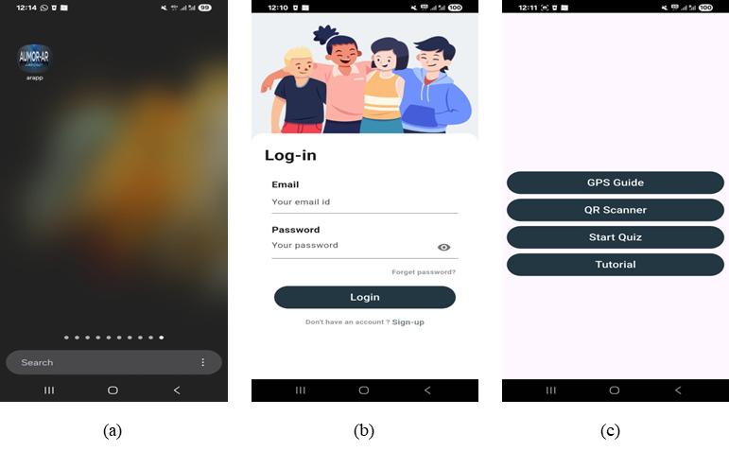
Figure 1. User interface flow of the application (a) AUMOR icon after installation on the phone, (b) login screen, (c) feature panel
  - GPS Integration for Location-Based Services
The app uses GPS-based navigation to deliver information when a student approaches a relevant place on campus. When students approach a point of interest such as a building, restaurant, or outdoor venue, the app activates an AR overlay that anchors to the scene and offers context-specific resources including web links, quick videos, maps, downloadable PDFs, and, where appropriate, simple booking. The students can see what matters for the spot in their surroundings resulting in reduced search time and help first-time visitors move confidently between locations and find their way. We marked key campus points of interest and recorded their precise coordinates using Google Maps. Each location was added to a lightweight JSON [46] catalog that stored its name, latitude/longitude, and AR contents to show on request.
The screenshots in Figure 2 illustrate the location-based information system of the AUMOR application. In the first panel shown in Figure 2(a), the system overlays a radar-style marker on the real-world environment to identify nearby locations, such as laboratories, classrooms, cafés, and library. Floating labels provide contextual information such as the name of the building or facility and its distance from the user enabling intuitive and location-aware navigations. Multiple markers in Figure 2(b) allow users to see several locations within the range, such as business buildings, computer labs, tutoring centers, and capstone project rooms providing a comprehensive situational overview, reducing the cognitive load required for navigation in unfamiliar environments. The third panel in Figure 2(c) shows the interactive information panel that is triggered when a user selects a location. This panel provides access to rich multimedia resources, including videos, documents, website links, room maps, and booking options. Such features extend the utility of AR beyond navigation, transforming it into an integrated learning and resource platform for orientation and daily campus use. Although GPS is primarily used for navigation and building-level positioning but at some location where GPS signals are weak or unavailable, the navigation is supported through QR code–based interaction.
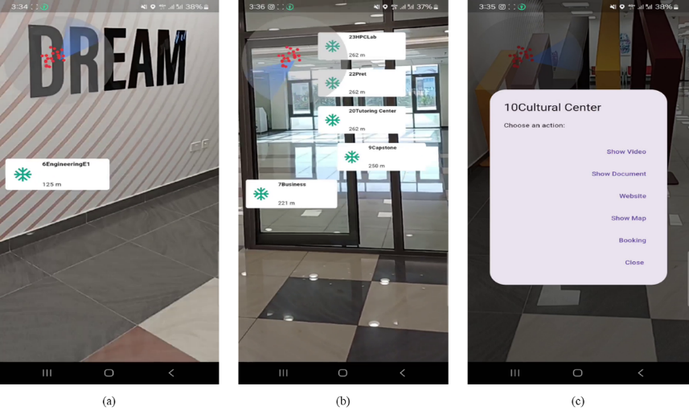
Figure 2. Augmented Reality navigation and resource interface of the AUMOR application
  - QR Code Implementation for Information Retrieval
We paired AR with QR codes placed on the key equipment encoding a resource name in plain text that the app reads with the camera and resolves against a lightweight JSON catalog mapping that text to an up-to-date content bundle. On scan, the app presents these options as an AR overlay (and accessible list view); tapping it opens the selected asset online. The contents are placed at a single repository to keep the app small while allowing centralized updates without reprinting codes. This scan-to-experience flow delivers just-in-time information for students working with diversified equipment in the lab or looking for staff members. Quick access to resources such as documentation and tutorial etc. helps students perform task without difficulty reducing friction and make learning experience more enjoyable.
The example QR code enabled information retrieval system designed to facilitate immediate access to technical resources for the Arduino Due board is shown in Figure 3(a), establishing a direct link between the physical hardware and relevant digital resources. When the QR code is scanned, it is decoded to plain text and system recognizes the device as “Arduino Due” and presents users with a structured set of contents such video tutorials, datasheets, official website access, schematic drawings, and contact details as shown in Figure 3(b). When users select the required option, website for example, they are redirected to the official Arduino documentation portal as shown in Figure 3(c). This highlights the pedagogical and practical value of embedding QR codes into engineering education contexts, as it effectively bridges physical components with digital learning environments, promotes self-directed inquiry, and ensures learners’ engagement with current and reliable technical content. This functionality exemplifies how QR technology can support efficient knowledge acquisition by minimizing the cognitive and temporal effort required to locate appropriate resources.
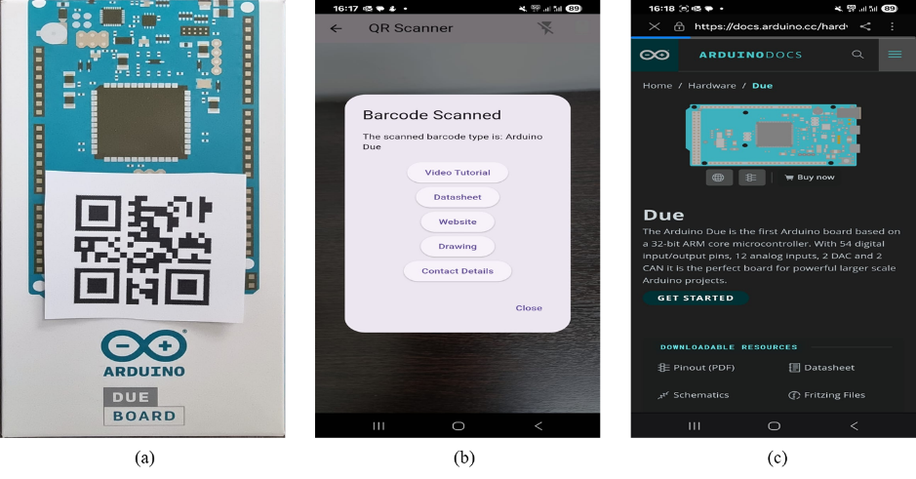
Figure 3. Workflow of QR code–based access to resources for the Arduino Due board.
- Methodology
  - Research Model and Hypotheses
This research uses the Technology Acceptance Model (TAM) to assess the level of users' acceptance of the mobile application being presented. It has been used as a methodology for the analysis of user acceptance of various ICT technologies such as smartphones, mobile banking, and mobile health care (Kim2019). TAM is recognized as one of the most powerful theoretical models explaining the behavior of users to adopt technology through the main perceptual factors such as Perceived Ease of Use (PEOU), Perceived Usefulness (PU), Attitude Toward Use (ATU), Behavioral Intention to Use (BI), and Actual Use (AU). According to the model, it is suggested that if the users perceive the technology neither requiring high physical and mental efforts nor only of great benefits but also very useful to the accomplishment of their tasks, they will be more willing to adopt it.
The following hypotheses were developed based on TAM constructs and the structure of the questionnaire:
- H1: PEOU has a positive effect on PU.
- H2: PU has a positive effect on ATU.
- H3: PEOU has a positive effect on ATU.
- H4: ATU positively influences BIU.
- H5: PU positively influences BIU.
- H6: BIU positively influences AU.
A graphical illustration of research hypotheses is also provided in Figure 4.
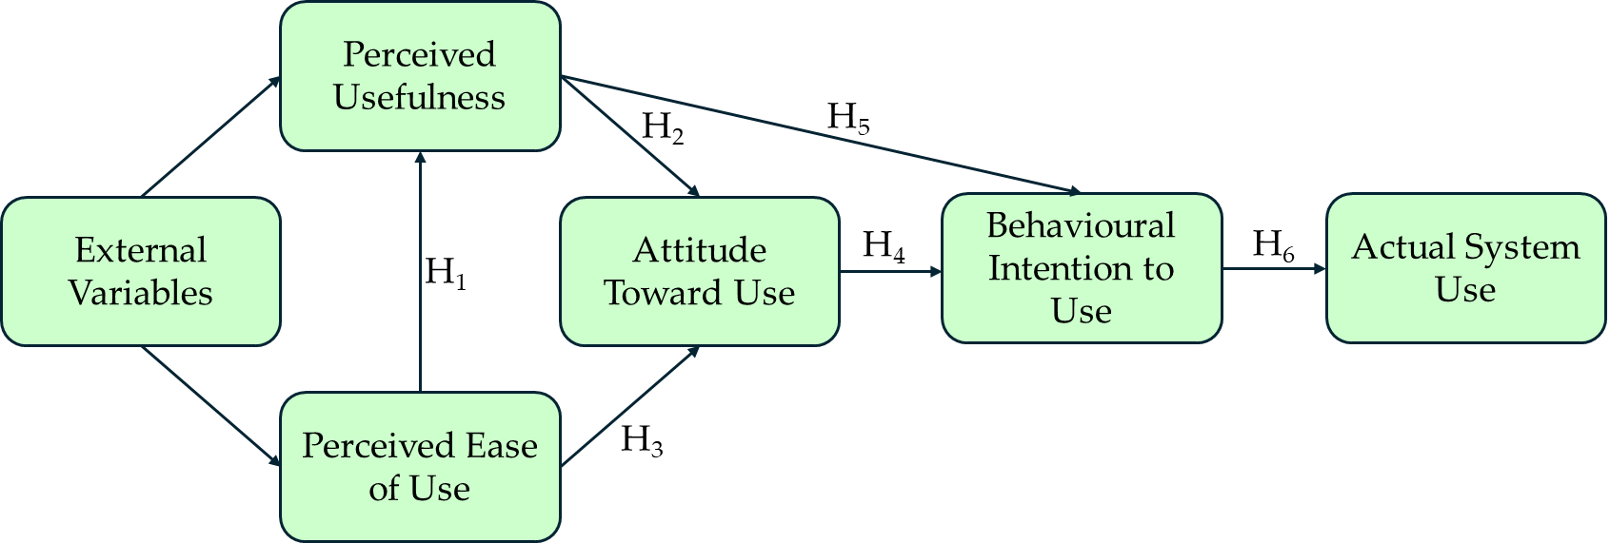
Figure 4. Illustration of TAM-based research hypothesis
  - Sampling Method and Participant Recruitment
A total of 128 participants, including undergraduate students and faculty members from the different departments of the university, took part in this research. It comprised 39.84% males and 60.16% females, with their current academic levels reported in Table 2 below. Most participants were junior (36.72%) or sophomore (31.25 %) students.
Table 2. Participant demographics
Characteristics | Attributes |  |  |  |  |  |  | Total
Participant Gender | Male (51) |  |  |  | Female (77) |  |  | 128
 | 39.84% |  |  |  | 60.16% |  |  | 100%
Participant Age (Years) | Freshmen | Sophomore | Junior | Senior |  | Faculty | Staff | 128
 | 12.50% (16) | 31.25% (40) | 63.72% (47) | 15.63% (20) |  | 3.13% (4) | 0.78% (1) | 100%
The primary target users of the AUMOR application are students; however, faculty participants were included during this pilot evaluation to provide additional perspectives on usability and informational clarity. Due to the limited number of faculty respondents, the data was analyzed at an aggregate level, and subgroup comparisons between students and faculty were not statistically meaningful. This design choice is explicitly acknowledged, and future studies will employ stratified sampling and group-wise analysis to examine potential differences between user roles. Also, the participants had prior experience with augmented reality, but it was not used as an inclusion or exclusion criterion for participation. Instead, participants self-reported their familiarity with AR applications as part of the demographic questionnaire. As reported in the Results section, the majority of participants indicated no prior experience with AR, while a smaller proportion reported limited prior exposure. This distribution suggests that the evaluation largely reflects the perceptions of first-time AR users, which is appropriate for a university orientation application intended for new students. This clarification strengthens the generalizability of the findings to typical campus populations.
Participants were recruited using a convenience sampling approach. Some students were enrolled in the course taught by researchers and participation was strictly voluntary. No academic credit or financial incentives were offered to the participants. The participants were selected in the sequences they contacted. No rewards or compensation were offered for participation, and they were informed that they could withdraw at any time without any consequences. If a participant decided to withdraw the next participant was contacted to take his place. The data was collected outside of teaching and assessment activities. The participating students and facilitators belonged to the engineering and business schools. Though this sampling strategy enabled efficient access to participants, it may introduce sampling bias and may limit generalizability. We explicitly acknowledged this limitation. Future work will address this by employing broader recruitment strategies, such as cross-departmental or multi-institutional sampling, to enhance external validity and reduce potential bias.
  - Research Procedure
In case of students agreeing to take part, a meeting was arranged in which the participant and researchers were present who performed the evaluation and described the research and the procedure for carrying out the test to the participant(s). Respondents were briefed about the study purpose, anonymity, and consent before participation. Participants were made aware that their involvement in the study was entirely voluntary and that they might leave at any moment without facing any repercussions. They were provided with an Android smartphone with a pre-installed orientation application (AUMOR) inside the campus. The application includes a video tutorial to guide students and reduce their dependence on external assistance. After using the application, the participants were demanded to fill in a paper-based form evaluating comfort, usefulness, and helpfulness. The data was collected over a period of one month during summer 2025.
  - Instrument Design
We used a structured questionnaire as a primary instrument for collecting data which was adopted from established TAM instrument reported in literature to ensure content validity. It was adapted with a few adjustments and rewordings to align with the university orientation and AR application context. The survey used in this research was derived from TAM original measurement scales [41] as well as from other literatures [47], [48], [49], [50]. The final instrument contained 23 items, divided into six distinct sections for logical flow as shown in Table 3.
Table 3. TAM constructs, design features, and survey items
Section | Construct and Items | Design Features | Reference
Section 1  Q1–Q4 | Participant Demographics | N/A
Section 2  Q5–Q9 | Perceived Usefulness (PU) | -GPS-based outdoor navigation  -Context-aware AR overlays  -Real-time access to campus information | [41], [51]
 | PU1: The AR application helps me better understand the university campus layout.
 | PU2: The AR application provides useful information about campus facilities
 | PU3: The AR application improves my overall orientation experience.
 | PU4: Using the AR application saves time in finding important campus locations.
 | PU5: The AR application enhances my confidence in navigating the campus.
Section 3  Q10–Q15 | Perceived Ease of Use (PEOU) | -Simple and intuitive user interface  -QR-based indoor interaction  -Minimal navigation steps | [41], [52]
 | PEU1: It is easy to find information about different locations using the AR application.
 | PEU2: The AR application is simple to learn and use.
 | PEU3: I do not need additional instructions to understand how to use the AR app.
 | PEU4: The AR app responds quickly to my interactions (e.g., tapping, swiping).
 | PEU5: The layout and design of the AR application are user-friendly.
 | PEU6: I find it difficult to use the AR application.
Section 4  Q16–Q19 | Attitude Towards Use (ATU) | -Smooth AR interaction  -Consistent system responsiveness  -Visually engaging AR content | [41], [50], [53]
 | ATU1: I find the AR application to be a fun way to explore the campus.
 | ATU2: I enjoy using the AR application during orientation.
 | ATU3: I believe using the AR app is a good idea for campus orientation.
 | ATU4: I feel confident when using the AR application to navigate the university.
Section 5  Q20–Q22 | Behavioural Intention to Use (BIU) | -Reliable performance  -Practical orientation support  -Relevance for new students | [41], [49]
 | BIU1: I will recommend this AR application to other students or new entrants.
 | BIU2: I would prefer using an AR application over traditional methods for orientation.
 | BIU3: I plan to continue using the AR application during my time at the university.
Section 6  Q23 | Actual Use (AU) | -Repeated access to -AR features  -Continued use dur-ing orientation tasks | [41]
 | AU1: How frequently did you use the AR application during your orientation?
All Likert items used a 5-point scale: 1 = Strongly Disagree to 5 = Strongly Agree.
  - Instrument Validity and Reliability
The internal consistency reliability of each TAM construct was assessed using Cronbach’s alpha, with values exceeding accepted thresholds for exploratory and applied research. Pearson correlation analysis was conducted to examine relationships among TAM constructs and test the proposed hypotheses. Statistical significance was evaluated using p-values, with a threshold of p < 0.001, consistent with prior TAM-based studies. This analytical approach provides a transparent and reproducible method for evaluating user acceptance relationships within the proposed framework.
  - Research Ethics
This study involved human participants and required approval from the concerned authorities. The protocol was approved by the research committee at AUM. The research required interactions faculty conducting the survey and the participants. Therefore, the researcher was aware of the participants’ identities, and anonymity was not possible. The questionnaire provided to the participants was anonymous and did not obtain any information that could help to identify them.
- Results
In this section, we present the evaluation results of AUMOR application. The app was tested in real-life. The data collected were analyzed using R software (version 4.0.3). The internal consistency of the survey was very good, with a Cronbach’s alpha of .928. Broken down by subscale, the internal reliability for all constructions is provided in Table 3 with all values exceeding the recommended threshold of 0.7 [54], [55] indicating good internal consistency. Table 4 presents a summary of the descriptive statistics, reliability, and distributional characteristics of the studied constructs. PU and ATU (Q16Q19) possess the greatest mean scores (M = 3.80 and M = 3.81, respectively), reflecting the overall positive user perception, and both have high levels of internal consistency (Cronbach's = 0.837 and 0.822). PEOU reveals an average mean (M = 3.40) with a level of reliability ( = 0.734) deemed satisfactory; however, its high negative skewness (1.90) and elevated kurtosis (5.89) indicate that most responses were at the upper end of the scale. BIU also achieves a good mean (M = 3.74) and high reliability ( = 0.828), with its skewness and kurtosis figures falling within the acceptable range. Actual Use has the average value of 3.69 (SD = 0.91), and it is indicative of moderate levels of usage; since it is a single, item measure, the question of internal consistency does not arise, however, its distribution shows negative skewness (1.51) and kurtosis of a moderate level (3.16). Collectively, these findings demonstrate that the multi, item constructs have satisfactory levels of reliability, and the distributional properties are also acceptable, thus the constructs are appropriate for subsequent inferential analyses.
Table 4. Reliability of constructs based on Cronbach’s alpha.
Construct | Items | Mean | Std. Dev. | Cronbach’s α | Skewness | Kurtosis
Perceived Usefulness | Q5 - Q9 | 3.80 | 0.65 | 0.837 | -0.83 | 2.97
Perceived Ease of Use | Q10 - Q15 | 3.40 | 0.55 | 0.734 | -1.9 | 5.89
Attention to Use | Q16 – Q19 | 3.81 | 0.73 | 0.822 | -1.82 | 4.68
Behavioral Intention to Use | Q20 – Q22 | 3.74 | 0.86 | 0.828 | -1.22 | 1.69
Actual Use | Q23 | 3.69 | 0.91 | - | -1.51 | 3.16
The correlation coefficients and their statistical significance (p-values) for all hypotheses are provided in Table 5. All the relationships are positive and statistically significant (p < 0.001), meaning there is strong evidence supporting each hypothesized path in the TAM model. The strongest effect is ATU → BIU (r = 0.803), showing that attitude toward use is the most influential factor in shaping behavioral intention. The lowest but still significant is PEOU → PU (r = 0.499), suggesting that perceived ease of use moderately enhances perceived usefulness.
Table 5. Correlation analysis of hypothesis.
Hypothesis | Relationship | Correlation | p-value | Interpretation
H1 | PEOU → PU | 0.499 | < 0.001 | Moderate positive correlation
H2 | PU → ATU | 0.619 | < 0.001 | Strong positive correlation
H3 | PEOU → ATU | 0.758 | < 0.001 | Strong positive correlation
H4 | ATU → BIU | 0.803 | < 0.001 | Very strong positive correlation
H5 | PU → BIU | 0.678 | < 0.001 | Strong positive correlation
H6 | BIU → AU | 0.665 | < 0.001 | Strong positive correlation
Approximately one-third of the participants (32.81%, n=42) reported using mobile applications for educational purposes often, and over a third (35.15%, n=45) said they sometimes did so and only a small minority reported minimal engagement, with 4.69% using them rarely and 1.56% never using them. Regarding familiarity with AR, most respondents (57.03%, n=73) have not used an AR app before, while 40.63% (n=52) reported prior AR use, and 2.34% (n=3) did not answer. This means that the proposed AR app is new to many students, which helps explain the sizable neutral responses in ease-of-use/usefulness items; many are first-time users still forming opinions.
The breakdown of the perceived usefulness (PU) of the application is shown in Figure 6. Most of the students found the AUMOR was useful for understanding the university campus layout (60.16%, n=77), finding useful information about campus facilities (75%, n=96), and overall orientation experience (57.82%, n=74). For most participants (74.22%, n=95), using the AR app saved time in finding important campus locations, and it helped with confident campus navigation (57.03%, n=73).
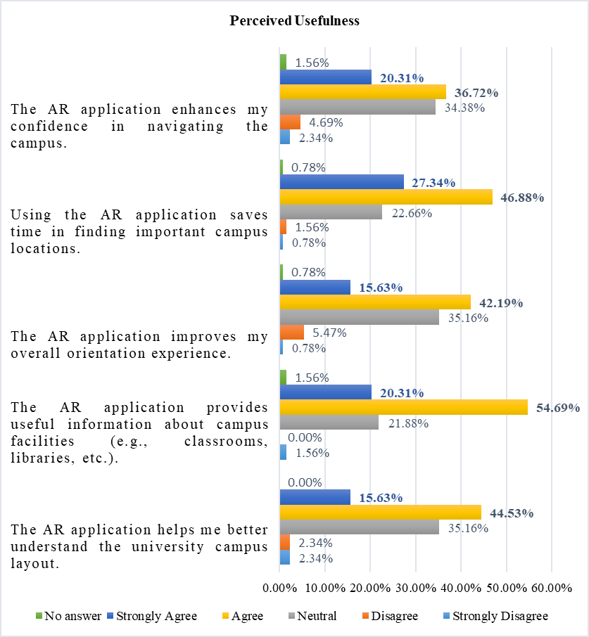
Figure 5. Breakdown of perceived usefulness of the AR application.
Figure 6 shows a breakdown of the perceived ease of use (PEOU) and most of the survey participants found information about different campus locations easily using the application (71.88%, n=92). They also found the AUMOR app simple to learn and use (70.32%, n=90) and did not require additional instructions to understand how to use the application (49.22%, n=63). The AR app was quick to respond according to 54.68% (n=70) of the survey participants, with a user-friendly layout and design (66.41%, n=85), and it was not difficult to use (52.35%, n=67).
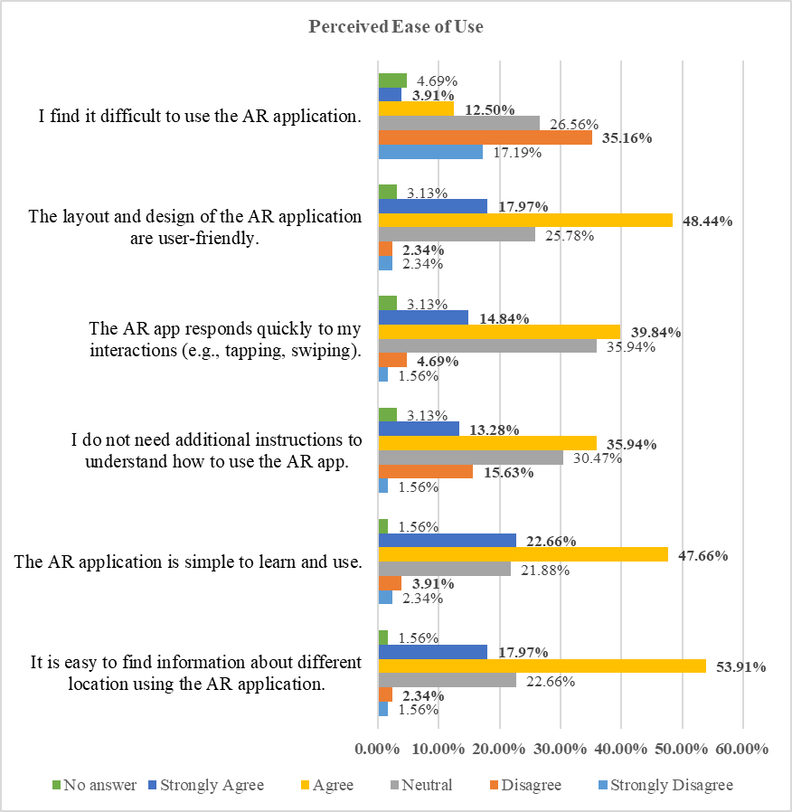
Figure 6. Breakdown of the perceived ease of use of the AR application.
The ATU results were broadly positive Figure 7. Students strongly endorsed the concept, with 75.79% (n=97) believing that using the AUMOR app for orientation was a good idea, with only 2.34% (n=3) disagreeing and 18.75% (n=24) neutral. They also found it engaging, as 71.10% (SA+A, n=31) said that the app was a fun way to explore the campus, while only 8.59% disagreed and 17.19% were neutral. Personal experience was solid but mixed with 58.60% (n=75) feeling confident when navigating the app, while 30.47% (n=39) were neutral and only 7.04% disagreed. Similarly, 53.91% (SA+A, n=69) enjoyed using it during orientation, with a relatively high 35.94% (n=46) neutral and 6.25% (n=8) negative responses. Non-responses were small (3% for each item). In short, students demonstrate the acceptance of the idea AR, but a sizeable neutral block on confidence and enjoyment suggests room for improvement to convert the undecided into enthusiastic users.
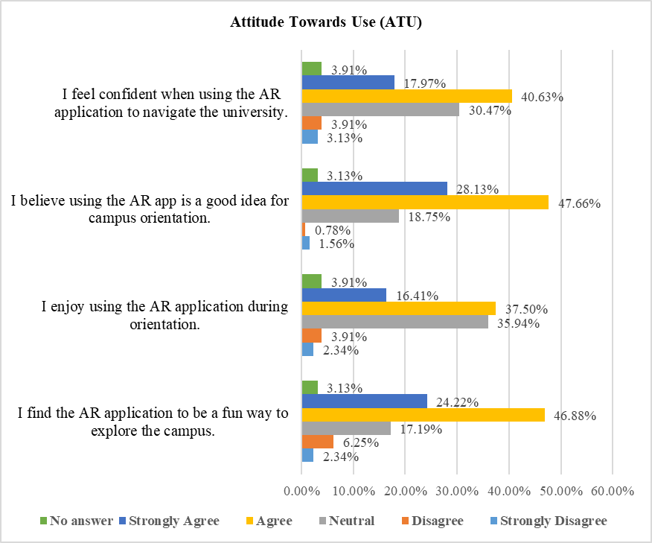
Figure 7. Breakdown of attitude towards the use of the AR application.
The Behavioral Intention to Use (BIU) results shown in Figure 8 are strong overall as 75.0% (n=96) would recommend the AR app to other students, with only 7.03% (n=9) negative and 14.84% (n=19) neutral. Preference over traditional orientation methods were positive but more mixed with 53.9% (n=69) favoring the AR approach, while 29.69% (n=38) are neutral and 11.72% (n=15) disagree, suggesting many are open to AR but still comparing it with familiar formats. The intent to continue using the app during university was similarly moderate with 52.35% positive (SA+A, n=67), 32.81% (n=42) neutral, and 10.16% (n=13) negative.
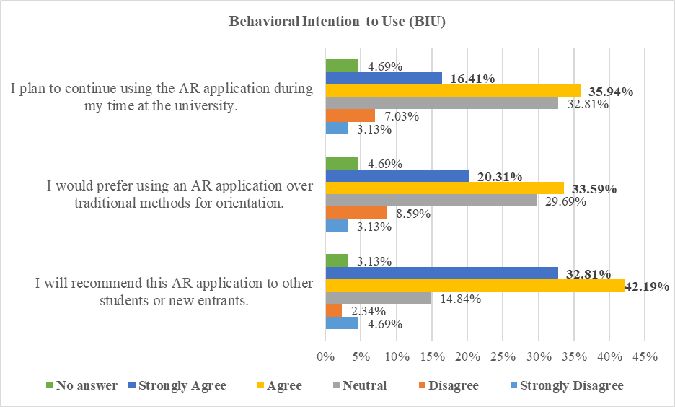
Figure 8. Breakdown of the behavioral intention to use AR application.
Figure 10 shows the intended use of the AR application after orientation. Most of the survey participants were likely or very likely to continue using the AR application after the orientation (57.03% of the total).
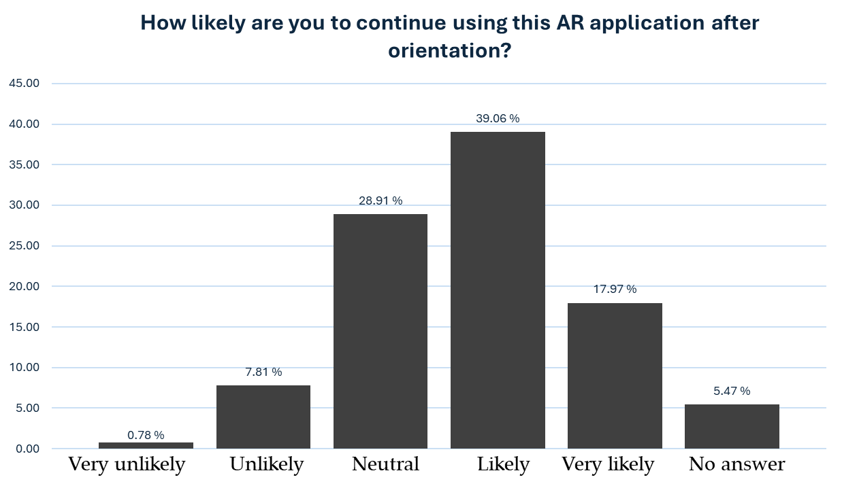
Figure 10. Intended usage of the AR application after the orientation
The results of hypothesis testing for this AUMOR, given in Table 6, reveal that all paths of the model, as suggested, are supported by the data. More specifically, the PEOU has a strong influence on PU, which means that people tend to view a system as more useful if they find it easier to use (H1). PU and PEOU both result in positive user ATU (H2 and H3), which means that the experience of using the system and the recognition of the functionalities play a major role in establishing positive user attitudes. In addition, ATU and PU are factors that have a positive effect on the BIU (H4 and H5), which means that users are willing to use the AUMOR for a long time if they possess positive attitudes toward the system and perceive its benefits. Ultimately, BIU is a significant determinant of AU (H6), which means that the users are very likely to carry out the behavior they intend to. Overall, the results strongly support the theoretical framework of the Technology Acceptance Model applied to the AUMOR.
Table 6. Hypotheses testing results
Hypothesis |  | Support
H1 | PEOU has a positive effect on PU. | Yes
H2 | PU has a positive effect on ATU. | Yes
H3 | PEOU has a positive effect on ATU. | Yes
H4 | ATU positively influences BIU. | Yes
H5 | PU positively influences BIU. | Yes
H6 | BIU positively influences AU. | Yes

- Discussion
The evaluation results presented in previous section confirm the potential of augmented reality combined with GPS and QR code technologies to improve the orientation experience of new students. PU received highest rating in terms of timesaving and facility information, reflecting that application successfully provides access to contextual information instantly at the point of need. This is compatible with earlier findings which suggest that mobile applications are valuable when they reduce effort and provide ease in performing real-world tasks. However, low scores for confidence in navigation and improvement in overall orientation experience were more moderate. This suggests that the application delivers the information but does not offer complete way finding solution for visitors.
The PEOU results were similarly promising finding the application simple to learn, intuitive for accessing information, and has user-friendly layout. These findings align with the core principles of the TAM, which emphasizes that PEOU is a key factor that influences the user acceptance and sustained engagement with technology [41]. Many other studies suggest that ease of use significantly predicts BI and AU, especially in educational technology contexts [12], [56]. Specifically, in AR-based learning environments, students who perceive systems as easier to navigate are more likely to develop positive attitudes and trust in the system [56]. Relatively weaker scores in system responsiveness and the expressed need for support indicate the areas needing the improvement. These concerns are coherent with outcomes of earlier research that emphasize the importance of system responsiveness and structured onboarding in AR applications to reduce cognitive load and anxiety [57], [58]. Since students were not familiar with AR technologies, the integration of improved tutorials could increase user because structured support materials and smooth interface feedback loops bridge initial resistance and improve the perceived ease of use [59], [60]. Furthermore, poor internet quality due the surrounding building might also contribute to the low scores to the system responsiveness. This could be overcome by making the contents available offline by embedding them in the application thus improving the response time of the system by removing dependence on internet and eliminating the request and response time altogether. But it comes at the cost as it can significantly increases the size of the application. Furthermore, it results in loss of flexibility and efficiency as it is not be possible to update or modify the content centrally. A recompilation of the application by developer and update on mobile from the user is needed as a result of any change in the content.
The results regarding attitude towards use show strong endorsement of AUMOR as nearly three-quarters of respondents favoured that using the app was a good idea for orientation, and a fun way to explore campus. These findings highlight that students view AR as functional and enjoyable, supporting the premise that perceived enjoyment can reinforce acceptance, as noted in the extended versions of the Technology Acceptance Model 3 (TAM3). However, indicators of confidence and personal enjoyment were somewhat lower with a sizable proportion of neutral responses suggesting that some students remain cautious or undecided about its reliability and personal value for practical use. Such hesitation is often linked to first-time exposure to AR technologies, as many of the participants never used AR before. Another reason for the low score can be the contribution of the senior students who have spent a lot of time at the university and do not perceive it the same way as the freshmen. This can be improved by including micro-onboarding, optimizing the performance to reduce lag, and improving indoor navigation accuracy. These measures can change neutral attitudes into more enthusiastic adoption, maximizing the impact of AUMOR.
The outcomes of behavioural intention were similarly promising as most of the students reported that they recommend the AR app to their peers, demonstrating a strong potential. More than half of the students expressed a preference for AR-based orientation over traditional methods and have the intentions to use it during their studies. These results suggest that AUMOR has a clear pathway for sustained adoption, provided that its reliability and relevance continue to improve. But many students were for both preference and continued which requires improvements so that it could be more beneficial students’ daily academic lives. Inclusion of extra feature such as real-time event reminders, updates on facilities, and academic service integration (grades, office hours) could embed the app into routine student practice. Aligning AR content with students’ immediate academic and administrative needs may transform the app from a one-time orientation aid to a long-term companion throughout their university journey. In line with TAM, the BIU findings underscore that positive attitudes and perceived usefulness drive the intention to use. By taking advantage of on high recommendation rates and addressing areas of concerns, universities can ensure that AUMOR become an integral part of the student experience, rather than a novelty used only at the start of the academic year.
This study is not without certain limitations. To start with, all information was gathered at only one institution, so the results can hardly be generalized. Second, instead of using computer records, the measure of usage depended on the participants' reporting of themselves. Third, the study method does not illustrate the long, term behavior of the user changes. Further research will be able to overcome these limitations if it includes a timeframe in addition to studies at different institutions and the use of objective data collection methods for user behavior analytics. These weaknesses confirm the findings of previous AR campus systems, which frequently encountered barriers related to technical stability, inclusivity, and scalability [61]. Because participants were recruited using convenience sampling from a single institution, the findings should be interpreted as indicative rather than fully generalizable, motivating future large-scale and multi-campus evaluations.
AUMOR offers several advantages when compared with earlier AR-based orientation initiatives applications. Early systems, such as those at Columbia University and Fu-Jen Catholic University, focused on head-mounted displays or AR visualization of campus landmarks thus require specialized hardware and offered limited scalability. More recently, Chung Hua University and the University of Quindío have used multimedia and 3D directional boards, but they lack GPS precision and QR code versatility. AUMOR’s hybrid approach, on the other hand, uses smartphone with both GPS and QR-triggered AR overlays successful achieving stronger accessibility and reducing the dependence on expensive hardware. AUMOR’s evaluation of 128 participants adds to the literature by providing a large-scale, empirical dataset. While studies at universities such as Bowling Green State or Haaga-Helia UAS focused on niche features (cultural exploration or missed orientation catch-up), AUMOR demonstrates the feasibility of embedding AR into mainstream orientation practices in higher education. Its integration of TAM as an evaluative framework also provides a theoretical contribution, bridging technology adoption theory with situated learning perspectives in the university orientation context.

- Conclusion
This study presents the design, implementation, and evaluation of the AR-based mobile to support student orientation through the integration of GPS, and QR code technologies. This application addresses the common challenges faced by the students who feel disoriented and time-pressed in large universities by providing location-based information as well as information about the equipment when performing experiments in the lab. The evaluation results indicated that students found the system useful for saving time and accessing facility information due to its clean design and simple interface contributing to their perceptions of ease of use. The interactive features, such as floating labels, multimedia resources, and quizzes, highlight engagement and learning potential of the application. The research contributes to the field of educational technology, advancing understanding of AR-assisted learning environments and technology adoption (TAM) in higher education. The findings suggest that student services offices can integrating AR applications into orientation activities to provide interactive experiences that promote engagement. Compared with previous AR-based orientation systems, AUMOR advances the field by combining affordability, scalability, and validation in a real-world context. Future work should focus on improving the application with real-time event updates, academic service integration, and accessibility options to support diverse student populations. It will also address the limitation of generalizability by recruiting larger and more balanced subgroups and conducting separate analyses for students and faculty, as well as controlling comparisons between novice and experienced AR users. The AUMOR has the potential to evolve into a comprehensive digital campus companion improved student engagement, time management, and well-being of students.

Author Contributions: Conceptualization, M.N. and M.O.; methodology, M.N., M.O., P.A., and H.O.; software, M.N., M.O., and P.A.; validation, M.N., M.O., P.A., and H.O., and S.B.; formal analysis, M.N., M.O., and P.A.; investigation, M.N., M.O., P.A., and H.O., and S.B.; resources, M.N., M.O., and H.O.; data curation, P.A., and H.O.; writing—original draft preparation, M.N., M.O., P.A., H.O., and S.B.; writing—editing and review, M.N., M.O., P.A., H.O., and S.B.; visualization, M.N., M.O., P.A., H.O., and S.B.; supervision, M.N. and M.O.; project administration, M.N; All authors have read and agreed to the published version of the manuscript.”
Funding: This research received no external funding
Institutional Review Board Statement: The survey was approved by the Research Committee at the American University of the Middle East (AUM), Kuwait (Project Identification Code: 2024_2025_SV001. Date of Approval: June 18, 2025).
Informed Consent Statement: Informed consent was obtained from subjects involved in the study.
Data Availability Statement: Data available on request.
Conflicts of Interest: The authors declare no conflicts of interest.

References
[1] M. Nadeem, M. Oroszlányová, A. Lushi, and W. A. Farag, “Bridging the gap: Analyzing skill demands in Kuwait’s electrical engineering job market to enhance employability of graduates,” Industry and Higher Education, vol. 39, no. 5, pp. 550–567, 2025.
[2] M. Nadeem, A. Chandra, A. Livirya, and S. Beryozkina, “AR-LaBOR: Design and assessment of an augmented reality application for lab orientation,” Educ. Sci. (Basel)., vol. 10, no. 11, p. 316, 2020.
[3] C. Feilberg, “In deep water: university students’ challenges in the processes of self-formation, survival or flight,” in Educational Dilemmas, Routledge, 2019, pp. 126–138.
[4] S. P. Moe, “Design and evaluation of a user-centric information system: Enhancing student life with mobile computing,” 2009, Institutt for datateknikk og informasjonsvitenskap.
[5] M. Mohzana, “The impact of the new student orientation program on the adaptation process and academic performance,” International Journal of Educational Narratives, vol. 2, no. 2, pp. 169–178, 2024.
[6] Department of Education, “Student services and amenities fee (SSAF) and SA-HELP,” Australian Government.
[7] R. Rashid, N. Annamalali, H. Saed, B. Yassin, and O. Alsmadi, “Developing an interactive university orientation app: Potential users’ feedback,” International Journal of Interactive Mobile Technologies, vol. 15, no. 22, pp. 165–171, 2021.
[8] P. Milgram, H. Takemura, A. Utsumi, and F. Kishino, “Augmented reality: A class of displays on the reality-virtuality continuum,” in Telemanipulator and telepresence technologies, Spie, 1995, pp. 282–292.
[9] Fortune Business Insights, “ugmented Reality Market Size, Share, Growth | Forecast [2024-2032],” 2024.
[10] A. Ulucan, K. B. Atici, and S. B. Sarac, “A university-wide orientation course timetabling model and its modification for pandemic period,” Opsearch, vol. 60, no. 4, pp. 1575–1602, 2023.
[11] N. Crozier, “Designing effective online orientation programs for first-year university students,” 2021.
[12] S. O. Mercer and A. La Marca, “Exploring Future Teachers’ Acceptance of Wearable Technologies for Anxiety and Stress Management: A TAM-Based Study”.
[13] Q. N. Naveed, H. Choudhary, N. Ahmad, J. Alqahtani, and A. I. Qahmash, “Mobile learning in higher education: A systematic literature review,” Sustainability, vol. 15, no. 18, p. 13566, 2023.
[14] L. Briz-Ponce, A. Pereira, L. Carvalho, J. A. Juanes-Méndez, and F. J. García-Peñalvo, “Learning with mobile technologies–Students’ behavior,” Comput. Human Behav., vol. 72, pp. 612–620, 2017.
[15] M. Nadeem, M. Lal, J. Cen, and M. Sharsheer, “AR4FSM: Mobile augmented reality application in engineering education for finite-state machine understanding,” Educ. Sci. (Basel)., vol. 12, no. 8, p. 555, 2022.
[16] A. Dwinggo Samala, L. Bojić, D. Bekiroğlu, R. Watrianthos, and Y. Hendriyani, “Microlearning: Transforming education with bite-sized learning on the go—insights and applications,” International Journal of Interactive Mobile Technologies (iJIM), vol. 17, no. 21, 2023.
[17] V. P. Chandran et al., “Mobile applications in medical education: A systematic review and meta-analysis,” PLoS One, vol. 17, no. 3, p. e0265927, 2022.
[18] M. Nadeem, W. Farag, Z. Uykan, and M. Helal, “Applications of machine learning in operational aspects of academia: a review,” International Journal of Evaluation and Research in Education (IJERE), vol. 13, no. 5, pp. 2843–2863, 2024, doi: http://doi.org/10.11591/ijere.v13i5.29324.
[19] C. J. Hegarty, “The global positioning system (GPS),” in Springer handbook of global navigation satellite systems, Springer, 2017, pp. 197–218.
[20] T. J. Soon, “QR code,” synthesis journal, vol. 2008, no. 3, pp. 59–78, 2008.
[21] C. Bhadane and K. Shah, “Context-aware next location prediction using data mining and metaheuristics,” Evol. Intell., vol. 14, no. 2, pp. 871–880, 2021.
[22] F. Alsubaiei, A. Alhendi, K. Alkhalifa, S. Alsharaf, A. Alfoudari, and M. Nadeem, “OGAR: Augmented Reality Application for Assisting Workers in the Oil and Gas Industry,” Proceedings of the IEEE International Multi Topic Conference, INMIC, no. 2024, 2024, doi: 10.1109/INMIC64792.2024.11004414.
[23] D. Li, M.-C. Chuah, and L. Tian, “Lehigh explorer augmented campus tour (LACT),” in Proceedings of the 2014 workshop on Mobile augmented reality and robotic technology-based systems, 2014, pp. 15–16.
[24] C. G. Low and Y. L. Lee, “SunMap+: An intelligent location-based virtual indoor navigation system using augmented reality,” 2014.
[25] S. Feiner, B. MacIntyre, T. Höllerer, and A. Webster, “A touring machine: Prototyping 3D mobile augmented reality systems for exploring the urban environment,” Personal Technologies, vol. 1, pp. 208–217, 1997.
[26] T.-L. Chou and L.-J. ChanLin, “Augmented reality smartphone environment orientation application: a case study of the Fu-Jen University mobile campus touring system,” Procedia-Social and Behavioral Sciences, vol. 46, pp. 410–416, 2012.
[27] J. Garay-Cortes and A. Uribe-Quevedo, “Location-based augmented reality game to engage students in discovering institutional landmarks,” in 2016 7th International Conference on Information, Intelligence, Systems & Applications (IISA), IEEE, 2016, pp. 1–4.
[28] N. Nguyen, T. Muilu, A. Dirin, and A. Alamäki, “An interactive and augmented learning concept for orientation week in higher education,” International Journal of Educational Technology in Higher Education, vol. 15, no. 1, pp. 1–15, 2018, doi: 10.1186/s41239-018-0118-x.
[29] F. G. Hamza-Lup, J. P. Rolland, and C. Hughes, “A distributed augmented reality system for medical training and simulation,” arXiv preprint arXiv:1811.12815, 2018.
[30] C. Carbonell Carrera and L. A. Bermejo Asensio, “Landscape interpretation with augmented reality and maps to improve spatial orientation skill,” Journal of Geography in Higher Education, vol. 41, no. 1, pp. 119–133, 2017.
[31] J. T. Chao, L. Pan, and K. R. Parker, “Campus event app-new exploration for mobile augmented reality,” Issues in Informing Science and Information Technology, vol. 11, no. 1, pp. 1–11, 2014.
[32] K.-M. Yu, J.-C. Chiu, M.-G. Lee, and S.-S. Chi, “A mobile application for an ecological campus navigation system using augmented reality,” in 2015 8th International Conference on Ubi-Media Computing (UMEDIA), IEEE, 2015, pp. 17–22.
[33] B. Al Delail, L. Weruaga, and M. J. Zemerly, “CAViAR: Context aware visual indoor augmented reality for a university campus,” in 2012 IEEE/WIC/ACM International Conferences on Web Intelligence and Intelligent Agent Technology, IEEE, 2012, pp. 286–290.
[34] F. D. Giraldo, E. Arango, C. D. Cruz, and C. C. Bernal, “Application of augmented reality and usability approaches for the implementation of an interactive tour applied at the University of Quindio,” in 2016 IEEE 11th Colombian Computing Conference (CCC), IEEE, 2016, pp. 1–8.
[35] U. Özcan, A. Arslan, M. İlkyaz, and E. Karaarslan, “An augmented reality application for smart campus urbanization: MSKU campus prototype,” in 2017 5th International Istanbul Smart Grid and Cities Congress and Fair (ICSG), Ieee, 2017, pp. 100–104.
[36] M. Batty and P. Kyaw, “Vector-based location finding for context-aware campus,” in 2009 Fifth International Conference on Wireless and Mobile Communications, IEEE, 2009, pp. 116–121.
[37] A. Walsh, “QR Codes–using mobile phones to deliver library instruction and help at the point of need.,” Journal of information literacy, vol. 3, no. 1, pp. 55–65, 2010.
[38] C. Sur, “Use of QR Codes in Promoting Library Resources and Services: A Study of Review of Literature”.
[39] M. Padmaja, K. Geethasri, J. S. Kousik, M. Vaishnavi, B. K. Sai, and D. L. Nayak, “Campus Routing Using QR Code,” in Journal of Physics: Conference Series, IOP Publishing, 2022, p. 12060.
[40] V. P. Dennen, S. Hao, S. Lee, and T. Lim, “Virtual Enhancement to Physical Spaces: A QR code based orientation game,” The Journal of Emerging Learning Design, vol. 2, no. 1, 2015.
[41] F. D. Davis, “Perceived usefulness, perceived ease of use, and user acceptance of information technology,” MIS quarterly, pp. 319–340, 1989.
[42] F. D. Davis, A. Granić, and N. Marangunić, “The technology acceptance model 30 years of TAM,” Technology (Singap World. Sci)., vol. 1, no. 1, pp. 1–150, 2023.
[43] A. Tashildar, N. Shah, R. Gala, T. Giri, and P. Chavhan, “Application development using flutter,” International Research Journal of Modernization in Engineering Technology and Science, vol. 2, no. 8, pp. 1262–1266, 2020.
[44] A. TĂBUȘCĂ, C. Coculescu, and M. Pîrnău, “FLUTTER TECHNOLOGY AND MOBILE SOFTWARE APPLICATIONS.,” Journal of Information Systems & Operations Management, vol. 16, no. 2, 2022.
[45] W. Wu, “React Native vs Flutter, Cross-platforms mobile application frameworks,” 2018.
[46] P. Bourhis, J. L. Reutter, and D. Vrgoč, “JSON: Data model and query languages,” Inf. Syst., vol. 89, p. 101478, 2020.
[47] K. Mouloudj et al., “Factors influencing the adoption of digital health apps: an extended technology acceptance model (TAM),” in Integrating Digital Health Strategies for Effective Administration, IGI global, 2023, pp. 116–132.
[48] H. Jeong, “An investigation of user perceptions and behavioral intentions towards the e-library,” Library Collections, Acquisitions, and Technical Services, vol. 35, no. 2–3, pp. 45–60, 2011.
[49] N. Kim, Y. Park, and D. Lee, “Differences in consumer intention to use on-demand automobile-related services in accordance with the degree of face-to-face interactions,” Technol. Forecast. Soc. Change, vol. 139, pp. 277–286, 2019.
[50] V. Venkatesh, M. G. Morris, G. B. Davis, and F. D. Davis, “User acceptance of information technology: Toward a unified view,” MIS quarterly, pp. 425–478, 2003.
[51] H. Kim, Y. Kwon, H. Lim, J. Kim, Y. Kim, and W. Yeo, “Recent advances in wearable sensors and integrated functional devices for virtual and augmented reality applications,” Adv. Funct. Mater., vol. 31, no. 39, p. 2005692, 2021.
[52] S.-M. Jeon and K.-S. Kim, “Design and Implementation of Piping Spool Management Android Application using QR Code,” Journal of Digital Contents Society, vol. 13, no. 4, pp. 609–616, 2012.
[53] P. Zhang, S. N. Aikman, and H. Sun, “Two types of attitudes in ICT acceptance and use,” Intl. Journal of Human–Computer Interaction, vol. 24, no. 7, pp. 628–648, 2008.
[54] J. Wang, S. Zhao, W. Zhang, and R. Evans, “Why people adopt smart transportation services: An integrated model of TAM, trust and perceived risk,” Transportation Planning and Technology, vol. 44, no. 6, pp. 629–646, 2021.
[55] A. C. Bouarar et al., “Antecedents of Sustainable Agriculture Entrepreneurial Intentions: Extending the TPB With Social Media Influencers,” in Digitizing Green Entrepreneurship, IGI Global Scientific Publishing, 2025, pp. 205–230.
[56] D. P. Putri, “Augmented Reality Implementation in Financial Regulatory Education for Indonesian High School Students,” Augmented Reality Implementation in Financial Regulatory Education for Indonesian High School Students.
[57] S. B. Bello, M. S. Abdurrahman, and U. S. Bebeji, “Artificial Intelligence in legal Education: Perceptions of ease of use and usefulness of CHATGPT among undergraduate law Students of Ahmadu Bello University, Zaria,” LexScriptio A Journal of the Department of Jurisprudence and Public Law, vol. 2, no. 1, pp. 81–94, 2025.
[58] M. A. M. M. Alsaid, T. M. Ahmed, S. Jan, F. Q. Khan, and A. U. Khattak, “A Comparative Analysis of Mobile Application Development Approaches: Mobile Application Development Approaches,” Proceedings of the Pakistan Academy of Sciences: a. Physical and computational sciences, vol. 58, no. 1, pp. 35–45, 2021.
[59] I. Buchem, F. Schmid, and A. Ermel, “Competency Recognition in AI Education: Investigating Higher Education Students’ Perceptions of Open Educational Badges Using Technology-Acceptance Model.,” Ubiquity Proceedings, vol. 6, no. 1, 2025.
[60] Y. Gong, C. Xu, S. Luo, and J. Lin, “Modeling teacher education students’ adoption of large language models through an extended technology acceptance framework,” Sci. Rep., vol. 15, no. 1, p. 32208, 2025.
[61] L. H. Wong, “Mobile campus touring system based on AR and GPS: A case study of campus cultural activity,” in Proceedings of the 21st International Conference on Computers in Education. Asia-Pacific Society for Computers in Education, Indonesia, 2013.

Disclaimer/Publisher’s Note: The statements, opinions and data contained in all publications are solely those of the individual author(s) and contributor(s) and not of MDPI and/or the editor(s). MDPI and/or the editor(s) disclaim responsibility for any injury to people or property resulting from any ideas, methods, instructions or products referred to in the content.

